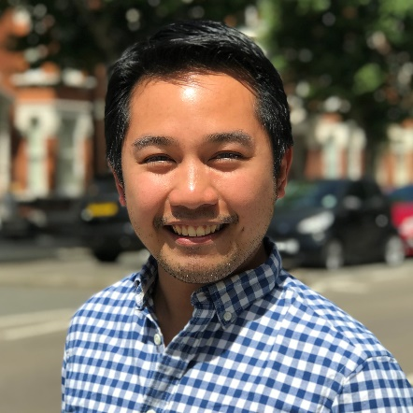
Renzo Guinto, MD DrPH is the Associate Professor of the Practice of Global Public Health and Inaugural Director of the Planetary and Global Health Program of the St. Luke’s Medical Center College of Medicine in the Philippines. Recently, he was also the Chief Planetary Health Scientist and Co-Founder of the Sunway Centre for Planetary Health in Kuala Lumpur, Malaysia. He is a member of the National Panel of Technical Experts of the Climate Change Commission of the Philippines, and convener of Planetary Health Philippines – a community of Filipino scholars and practitioners for advancing the new discipline of planetary health. An Obama Foundation Asia-Pacific Leader and Aspen Institute New Voices Fellow, Renzo has served as consultant for various organizations including the World Health Organization, World Bank, and Health Care Without Harm, and been a member of several international committees, advisory boards, and networks including three other Lancet Commissions and the editorial advisory board of The Lancet Planetary Health. Renzo obtained his Doctor of Public Health from Harvard University and Doctor of Medicine from the University of the Philippines Manila, and received further training from Oxford, Copenhagen, Western Cape, and East-West Center (Hawaii). He has traveled to and lectured in nearly 60 countries and 100 universities across the world; published more than 150 reports and articles in scientific journals, books, and popular media; and directed and produced short films that communicate the message of planetary healing to the world. In 2020, he was included by Tatler Magazine in its Gen.T List of 400 leaders of tomorrow who are shaping Asia’s future. In 2022, Renzo was named one of The Outstanding Young Men of the Philippines for his contributions to health and medicine and for pioneering the field of planetary health in the Philippines.

